

Addendum to the
2022-2023 Elmira College Graduate and Professional Studies Catalog

As of April 6, 2023

Masters of Science in Management program be reduced from 36.0 to 33.0 credit hours
ITM 5000 | Application of Technology in Business Setting | 3.0
MGT 5000 | Evaluating Research in Management | 3.0
MGT 5005 | Human Resource Management and Development | 3.0
MGT 5010 | Planning and Project Management | 3.0
MGT 5015 | Leadership | 3.0
MGT 5020 | Organizational Economics, Budget, and Finance | 3.0
MGT 5025 | Business Ethics | 3.0
MGT 5030 | Legal Environment of Business | 3.0
MGT 5035 | Managerial Economics | 3.0
MGT 5040 | Marketing Management | 3.0
MGT 5045 | Organizational Behavior | 3.0
 |  | 33.0

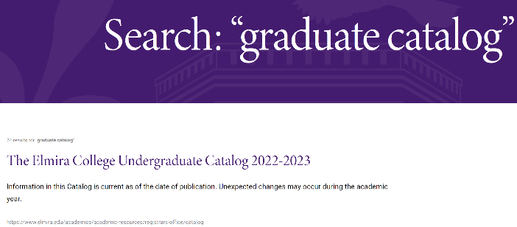
Matt, I think you may need to change this link title. When you do a search for the graduate catalog, you come up with this link that states Undergraduate in the link title, please change to Elmira College 2022-2023 Catalogs. Because when you click on this and you scroll down you then also see the Graduate Catalog. Please create whatever you would need to do for the searches for both Undergraduate and Graduate Catalogs.

https://www.elmira.edu/academics/academic-resources/registrars-office/catalog

Then create a new addendum like we list for the undergraduate - this will be new to the Graduate area: https://www.elmira.edu/academics/academic-resources/registrars-office/catalog

Current Graduate Bulletin and Professional Studies Catalog
Information in this Bulletin Catalog is current as of the date of publication. Unexpected changes may occur during the academic year. The listing of a course or program in this Bulletin Catalog, therefore, does not constitute a guarantee or contract that the particular course or program will be offered during a given year.
GRADUATE BULLETIN this button needs to state: Graduate and Professional Studies Catalog
Create this statement:

Addendum
- There is an addendum to the 2022-2023 Elmira College Graduate and Professional Studies Catalog listing recently approved change in credits for the Masters of Science in Management.

MATT - the information for the Addendum is listed at the beginning of this document and a separate pdf file for you to link to and for your guidance.

************************
THEN we have to have these additional areas updated as well:

https://www.elmira.edu/academics/graduate-programs/overview = clarify with Matt started here for the Graduate Management information

https://www.elmira.edu/academics/programs/management-ms for Matt

This is the information to list on elmira.edu - the only change is to the credits (is highlighted):
Elmira College’s Master of Science (MS) in General Management is designed around performance-based experiences that will build real-world skills and knowledge to prepare you for success in any industry.
The program consists of 33 credits of required coursework, including the capstone graduate seminar. It is designed for completion within a 15-month or a two-year time frame. For more information, please contact graduate@elmira.edu.

General Management
The Master of Science (MS) in General Management is designed for individuals planning a career in management, current managers, and individuals with aspirations for career advancement. It requires satisfactory completion of 12 courses totaling 33 semester credits. There are no electives. The degree is comprised of performance-based learning experiences intended to develop the essential knowledge and skill competencies required for general managers.

https://www.elmira.edu/academics/programs/management-ms/course-requirements for Matt

All the changes listed below are listed on the site: “Core Requirements”

Students must complete the following graduate-level management courses:
- ITM 5000 Application of Technology in a Business Setting | 3.00 Credit Hours - [Matt, please move this course to the top of the list]
- MGT 5000 Evaluating Research in Management | 3.00 Credit Hours
- MGT 5005 Human Resource Management & Development | 3.00 Credit Hours
- MGT 5010 Planning & Project Management | 3.00 Credit Hours
- MGT 5015 Leadership | 3.00 Credit Hours
- MGT 5020 Organizational Economics, Budget & Finance | 3.00 Credit Hours
- MGT 5025 Business Ethics | 3.00 Credit Hours
- MGT 5030 Legal Environment of Business | 3.00 Credit Hours
- MGT 5035 Managerial Economics | 3.00 Credit Hours
- MGT 5040 Marketing Management | 3.00 Credit Hours
- MGT 5045 Organizational Behavior | 3.00 Credit Hours
- MGT 6000 Graduate Seminar in Management | 3.00 Credit Hours

General Business Concentration
- Business Ethics
- The Legal Environment of Business
- Managerial Economics
- Marketing Management
- Organizational Behavior
Total credit hours = 36 33.0 credits [Matt, after the General Business Concentration listing, the statement changes to 33.0]

Spring II
MGT 5035 Managerial Economics
MGT 6000 Graduate Seminar in Management
Summer II
MGT 5000 Evaluating Research in Management
MGT 6000 Graduate Seminar in Management

